Guest Blog: Gratefully Giving forward by Professor Sally Brown

This January, I am thrilled to welcome Professor Sally Brown to the Grateful Academic. An internationally renowned educator, Sally is the author, co-author, editor or co-editor of over thirty books on learning, teaching and assessment. A true advocate for teaching academics, Professor Brown was instrumental in the set-up of the National Teaching Fellowship Scheme, which since 2000 has recognised and celebrated over 1000 academics who have made an outstanding impact on student outcomes and the teaching profession in higher education.

She writes her blog about what grateful late-stage or retired academics can do to pay forward the help they've had during their own careers, to help boost the working lives of the next generation.
-
Pay it forward / pey it fawr-werd / idiom an act of kindness for someone to reflect that someone else has done something kind for you
-
I was extremely fortunate in a non-continuous forty+ year career in Higher Education to encounter some fantastic role models and mentors who helped me achieve far more than I ever expected when I was new to HE teaching aged 27, tutoring for the Open University. I retired from full-time employment eleven years ago for a life as an independent consultant, and here are some of the things I’ve learned can help to express gratitude to all those whose guidance, advice and support helped me on my way. So, if you are later career or just retired why not commit to:

- Helping newer colleagues to build their professional networks: sometimes people ask my advice, and the most useful thing I can do is point them towards people who I know will have much more to say than I can on a topic. For example, recently an acquaintance doing a PhD on ‘intrapreneurship’ asked me about my favourite pedagogic models. Apart from pointing them towards the person whose four scholarships underpin my practice, Ernest Boyer (1990), I was also able to put them in contact with four people interested in related areas who are likely to have better reading lists than me!
- Taking a colleague along with you to a conference where you are presenting and helping them to meet people who might be helpful to them. It’s hard going into a mass of people at a conference if you know no-one and walking in alongside someone who has lots of friends, acquaintances and contacts there can make it all a little easier. If you can blag a free or reduced price place for them, all the better and if you can afford it, maybe subsidise a novice once in a while?
- Mentoring of all kinds, from very informal to more formal. My own style of mentoring turned out to be highly directive (“here’s five things you could try tight now!”) and not suitable for all, but went down well in some quarters. The unpleasant truth, however, is that any kind of mentoring is very time consuming. So the key thing for me was being clear from the outset what I would and would not do, (for example, I would expect the mentee to make the running in terms of meetings and national agendas, and I never committed to being the project chaser), and trying to be really supportive without being overpowering. It’s also important to be clear that this is a two-way transaction (mentoring colleagues is worthwhile for me as it keeps me up to date with current ideas/technologies and makes me feel good when I’ve really helped someone) and boundaries need to be set from the outset.
- Helping people thinking about going for new jobs to recognise their own strengths. I’ve lost count of the number of people (often women) who have needed to be reminded that you don't have to hit all the job description elements to give an application for a stretching job description a shot! Sometimes it’s a matter of asking people to talk about what they already do, and helping them to reframe/articulate the value of what they are doing in terms of experience, capabilities and knowledge, in words that will go down well on a job application. And the simple advice to match these against the job description/person specification in the application can make a massive difference, as can helping them to identify what kinds of questions are likely to arise in an interview by thinking what could the interviewers reasonably ask in relation to the job description and person specification.
- The next step on from this is helping them plan for the promotion they might be going for in 5 years' time by developing an evidence-base of demonstrate impact and outcomes. What kinds of training/shadowing/CPD are likely to stretch their capabilities and give them useful experiences? What committees and working parties can they volunteer for, that will provide a broader experience-base? What boring and not always renumerated opportunities could they take up (e.g. Course leader) that might be regarded as essential for promotion? (I was told more than once in PVC/DVC interviews that my lack of experience as a Head of Department/Dean was unhelpful to my applications, as I had come up through a different route).
- Giving advice on where to get your research published and helping with writing and publishing first articles/chapters. Often newer academics will sometimes be unrealistically ambitious in targeting top-flight journals, whereas experiences in publishing in less prestigious outlets in the early days might help newish writers ‘cut their teeth’ can help build confidence.
- Helping people get their first publication. Over the years I have edited 15 books and in curating an edited text I always made a point of including not just topflight authors, but also a proportion of first-timers, to help them get a step in the right direction. Towards the end of our careers there are lots of ways we can help, including writing supportive reviews of new authors’ work (where justified) and helping people find their way through the complexities of academic publications. However, most colleagues in the same situation as me, often get asked to ‘just’ read through a draft and give comments on its value. I am very selective about taking this kind of thing on, as word gets around that you are helpful and the requests can snowball, burying you in a snowdrift of time-consuming drudgery.
- Contributing to books, projects, blogs which have no apparent benefit to you but might help the person leading the initiative. Including established authors among your list of indicative authors can help a novice to get their publications/project off the ground. In fact, I nowadays largely write outside my core domain of assessment, if it is helpful to a newish colleague.
- Making your own resources freely available: as an independent consultant I have worked on projects and publications which have accrued payment, but alongside this I have also always been happy to share some (nowadays the bulk) of my materials. For example, during the pandemic, working alongside my friend and colleague Professor Kay Sambell we have a whole range of resources on assessment during Covid times https://sally-brown.net/kay-sambell-and-sally-brown-covid-19-assessment-collection/ which we placed on my website rather than in books or journal articles, because for the sector, speed of response was of the essence. It’s been a marvellous thing to do during lockdown because the work has had thousands of downloads and responses have been hugely positive (our work has been translated into Japanese and Spanish and used in Australasia, S America, Pacific Rim nations and, most widely, in Europe). An unexpected spin-off has been that Kay and I have been asked to do lots of paid-for workshops and keynotes on making assessment more authentic when time-constrained unseen exams can’t take place, which was not our original plan but has been very welcome at a time when visiting universities to do this kind of work has not been possible.
- Helping people gain professional accreditation, for example, Staff and Educational Development (SEDA) Fellowships, HEA fellowship through AdvanceHE, applications for National Teaching Fellowships and so on or promotions. This can be a hugely time-consuming task and inevitably I get asked to do this quite often. I therefore have a rule that if I don’t really know the candidate (for example for a Teaching and Learning professorship, where I am asked for external expert review), I keep the volume of work down to manageable levels by asking the university concerned to make a modest contribution to the local foodbank I support, Justice Prince http://www.justiceprince.co.uk/html/about.htm and if they aren’t prepared to pay up, I won’t accept the task.
- Being an informal cheerful listening ear over a cup of tea, mainly to dispel some of the negativity younger colleagues are likely to encounter from the 'miserable crew'. Being an early career academic can be a depressing role, because so many cynical colleagues will hark back to the ‘good old days’ (my riposte to this is generally to talk about the 40 years of misogyny and sexism I had to navigate in the course of my career, which actually weren’t at all good!). But especially when we have stepped away largely from the Academy, we can find comfort in the really positive aspects, like collegiality and generosity, as well as the joy of true intellectual stimulation from colleagues with very different stances from our own.

Whatever you choose to do, it’s a brilliant way (particularly in a pandemic) to continue to make a contribution and to help on the next generation, bringing challenge, fun, intellectual stimulation and lots of laughs!

Top tips:

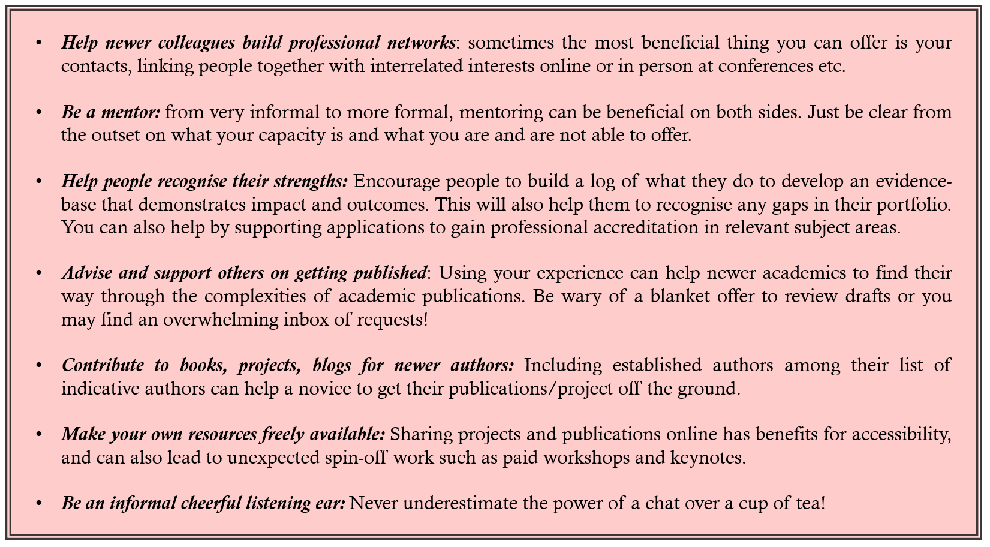

About the Author:

Professor Sally Brown is an Independent Consultant in Learning, Teaching and Assessment and Emerita Professor at Leeds Beckett University where she was, until 2010, Pro-Vice-Chancellor. She is also Visiting Professor at Edge Hill University, and formerly at the Universities of Plymouth, Robert Gordon, South Wales and Liverpool John Moores, and at Australian universities: James Cook, Central Queensland, and the Sunshine Coast. She holds Honorary Doctorates from the universities of Plymouth, Kingston, Bournemouth, Edinburgh Napier and Lincoln. She is a Principal Fellow of the Higher Education Academy, a Staff and Educational Development Association (SEDA) Senior Fellow and a National Teaching Fellow. Read more about her work at https://sally-brown.net/ and on twitter @ProfSallyBrown.

*This blog is also published at https://www.thegratefulacademic.com/post/guest-blog-gratefully-giving-forward-by-sally-brown
References
Advance HE: Applying for Fellowships https://www.advance-he.ac.uk/fellowship
Boyer, E. L., 1990. Scholarship reconsidered: Priorities of the professoriate. Princeton University Press, 3175 Princeton Pike, Lawrenceville, NJ 08648..
National Teaching Fellowships: https://www.advance-he.ac.uk/fellowship

