Compendium four: examples from Hong Kong
A further collection of authentic assessment resources collated by Sally Brown and Kay Sambell.

Introduction
Acting as External Consultants to an Advanced Study Institute (ASI) which brought together two Hong Kong universities to initiate a paradigm shift in university assessment, we are delighted to bring you a bumper bundle of case studies from the Education University of Hong Kong and Hong Kong Baptist University at HKSAR. We have run a number of joint workshops with these universities over the last year, and have been highly impressed with the ways in which their work demonstrates the value of our 6-step systematic approach to designing and embedding authentic assessment practices in diverse subject areas: see our website post on 17th August 2020 that describes this http://sally-brown.net/kay-sambell-and-sally-brown-covid-19-assessment-collection/
Firstly, we have four case studies from the Education University of Hong Kong which are from the disciplines of Language Studies (#1), English as a Second Language (#4), Education (#2), and Multiculturalism(#3). Second, we have nine cases from the Hong Kong Baptist University which cover: Finance (5), Chinese Medicine (#6), Multimedia Journalism (#7), Music (#8 and #13), Forensic analytical chemistry (#9), Medical Ethics (#10), Visual Arts practice (#11), and English Language Teaching (#12)
Diverse assessment activities illustrated in this compendium include ePortfolios, conference inputs, boardgames, posters, graphs and other graphic displays, images, postcards, photos, music performances and reviews, audio and video summaries, individual and group videos, cost-limited projects, reflection activities, live work with partners and critiques.
Notable elements include peer assessment, a focus on critical thinking, collaborative assessment, and a significant element of reflection in many of these, helping students to become more aware of themselves as learners and better able judge themselves.
Thanks so much to all the contributing authors for generously sharing their resources, to Professor Siu Cheung Kong of the Education University of Hong Kong and Dr Theresa FN Kwong of the Hong Kong Baptist University for helping us to collate these excellent examples, and to the senior managers at both universities for encouraging this initiative.
Our authors (in alphabetical order) are:
- Dr. Gray HO, Lecturer, Department of Chemistry, Hong Kong Baptist University
- Mr. Peter Benz, Associate Professor, Academy of Visual Arts, Hong Kong Baptist University
- Dr. Eugene Alexander Birman, Assistant Professor, Department of Music, Hong Kong Baptist University
- Mr. CHEUNG Chun Hoi, Assistant Professor of Practice, School of Chinese Medicine, Hong Kong Baptist University
- Mr. Dean C.K. COX, Senior Lecturer, Department of Journalism, Hong Kong Baptist University
- Professor TU Feng, Professor of Practice, School of Chinese Medicine, Hong Kong Baptist University
- Dr. Archimedes David Guerra, Lecturer, Department of Finance and Decision Sciences, Hong Kong Baptist University
- Dr. Ricky Lam, Associate Professor, Department of Education Studies, Hong Kong Baptist University
- Dr. Sophia LAM, Assistant Professor, from the Department of Chinese Language Studies, at The Education University of Hong Kong
- Dr. Winnie LAM, Associate Head and Senior Lecturer, Department of Mathematics and Information Technology, at The Education University of Hong Kong
- Dr. Jennie LI, an Assistant Professor, Department of Chinese Language Studies, at The Education University of Hong Kong
- Dr. Camilo MENDEZ, Assistant Professor, Department of Music, Hong Kong Baptist University
- Dr. Kevin YUE, Associate Professor, School of Chinese Medicine, Hong Kong Baptist University, Hong Kong SAR
- Dr. Kevin YUNG, Assistant Professor from the Department of Curriculum and Instruction, The Education University of Hong Kong.

We are proud to present our Hong Kong examples below.

- Dr. Sophia LAM, an Assistant Professor from the Department of Chinese Language Studies at The Education University of Hong Kong
Course: Cantonese and Hong Kong Local Culture

Context
As this class encourages students to explore Cantonese culture using various media, including movie, television, radio broadcast and music, an ePortfolio is a suitable alternative assessment that allows students to present their materials and analyses in a more dynamic and creative manner to more traditional assessment tasks. Unlike traditional exams, such authentic assessment can hone students’ critical thinking and problem-solving skills more effectively since they need to use a new multifunctional platform to construct and present their arguments.

Traditional Assessment:
Students were previously required to complete an exam testing their knowledge of the historical development, language features and local culture of the Cantonese language. Types of exam questions include short-answer and multiple-choice questions, textual analysis and illustration, requiring students to memorize and apply what they have learnt without much reflection.

Authentic Assessment: Media Analysis in ePortfolio
In this enhanced approach, students can choose either Google Site (web page creation tool) or Mahara (electronic portfolio platform) to design their own webpages and add videos, photos with captions and jingles for illustration. Students also enjoy a higher degree of autonomy in terms of material selection and website layout, motivating them to explore and showcase their knowledge of Cantonese culture diversely.

Requirements of the Media Analysis.
Based on the classroom knowledge, analyse the features of language of the assigned or optional Cantonese television commercial by undertaking the following tasks: (1920 words equivalence)
1. Write an overview of the background of the commercial by identifying the theme and major content.
2. Analyse the means of expression in the commercial according to its establishing shot, camera technique and theme song. Students can include a variety of supporting evidence, such as videos, photos with description and music recording, to back up the arguments.
3. Analyse the language features of the commercial by identifying and explaining the characteristics of the use of language, such as homophonic puns, grammatical features, loanwords and code-mixing.
4. Write a comprehensive analysis of the relationship between the language features and the theme, as well as the means of expression. Justify their connections and explain the advertising effects.

Learning Outcomes:
- Demonstrate two Generic Intended Learning Outcomes (GILOs): problem-solving and critical thinking skills
- Show your understanding of the characteristics and historical development of the Cantonese language.
- Identify the characteristics of the Cantonese language system, in a way that demonstrates your understanding of them.
- Analyse the connotations of the local culture of Hong Kong as reflected by the Cantonese approach.

- Dr. Winnie LAM, the Associate Head and Senior Lecturer from the Department of Mathematics and Information Technology at The Education University of Hong Kong.
Course: The University ePortfolio (a Capstone General Education Course).

The University ePortfolio (UePortfolio) Course in The Education University of Hong Kong is designed to assist students to see their future selves as a university graduate or young professionals through reflecting on their educational journey. The course also aims to enlighten students about ways of developing as a university graduate engaged in lifelong learning and dedicated to living a worthy life.

Authentic Assessment: ePortfolio
Rather than undertaking a more traditional assessment, students need to write a reflective entry (600 words) on selected undergraduate experiences with two major elements. First, students should write a self-reflection on class sharing, discussions and after-class self-contemplation. Second, critical feedback on peer study group sharing and discussions should be included.
Students, moreover, need to reflect on selected undergraduate experiences. Students are required to deliver a 10-to-12-minute individual presentation of the ePortfolio. Students also need to create a 2000-word individual ePortfolio that contains video illustrations and is built on a coherent theme or a focus area consolidating undergraduate learning experiences.

Requirements of the ePortfolio:
- A personal, reflective, critical and integrated account of the student’s undergraduate experiences (e.g. Majors, minors, international exchange, and block practice or internship)
- Clear reference in their reflections to their higher order competencies
- Clear connections between experiences and aspects of the student’s life beyond the classroom
- The application of student’s beliefs, values and goals in projecting their own personal vision for developing into a person who can display professional excellence, think critically to make moral judgements, learn and engage in lifelong learning and live a worthwhile life
- Reflections on peer feedback (e.g. review, evaluations, comments) during class meetings and UePortfolio presentation sessions (evidenced by presentation videos inserted in their UePortfolios), or reflections from learning with peers.

Learning Outcomes:
- Communicate (orally and in writing) personally, reflectively and critically about their undergraduate experiences concerning the development of their general attributes and high order competencies.
- Make and reflect critically on connections between what students have learned in their undergraduate studies and specific areas of their personal lives and experiences beyond the classroom.
- Articulate students’ own beliefs, values and goals in line with directions of developing into a person who can display professional excellence, think critically to make moral judgements, learn and engage in lifelong learning and live a worthwhile life.

- Dr. Jennie LI, an Assistant Professor from the Department of Chinese Language Studies at The Education University of Hong Kong.
Course: Multiculturalism and International Mindedness.

This course aims to cultivate students’ multicultural awareness, by eliminating their cultural stereotypes, enhancing their senses of empathy for human beings, and encouraging them to appreciate the diversity in study and in daily life. Through doing a group video project, students can explore and analyse the experiences and voices of people with diverse backgrounds in the society they care about. By discussing, reflecting on and making sense of the group’s discovery with the peers alongside the instructor, students can hone their critical thinking skills and communication skills, as well as become global citizens equipped with widened cross-cultural perspectives and cultural sensitivity.

Authentic Assessment: Group Video Project Tasks
- Students form small groups (3-4) to conduct a 20-minute video project called “Voices of Diversity,” which aims at showing how group members may differ in their experiences, values, and perceptions on a topic based on the core concepts in multiculturalism and multicultural issues.
- Each group needs to show multicultural perspectives and international mindedness in the project and create a video product that can be shared with other classmates.
- Members of each group need to work collaboratively to think of dynamic, creative ways to explore the topic through scripting, creating, editing, and filming the video. The video should include appropriate photographs, video, music, graphs, and other visual aids.

Requirements of the Group Video Project. To be successful, students need to:
1. Convey a central message of the selected theme demonstrating analytical/critical/reflective thinking: The project should have an outstanding content presentation, exceptionally well-selected materials, and artifacts, with a clear theme and adequate description of how the video project will contribute to the overarching theme of this course.
2. Use and present relevant materials supporting the selected theme: Students should provide insightful and a variety of relevant references to their general competencies, with sufficient and thought-provoking reflection on multicultural perspectives and international mindedness, using concepts, theories, and approaches from the course lectures and assigned readings.
3. Display organizational systems in a logical flow: The video project should illustrate a clear structure with thumbnail sketches of each scene. Notes of proposed transitions, special effects, sound, and textual explanations of all scenes should be provided. The content needs to include a clear theme and be creative and thought-provoking. A rich variety of supporting information is required. Events and messages should be presented in a logical order, including properly cited sources.
4. Use appropriate language to engage the audience to deliver an effective presentation and manage good timing: Students should use imaginative, memorable, eloquent, and compelling language that could engage the viewers at all times. Excellent time management is also expected.
5. Demonstrate effective teamwork: All members should contribute to the project in a complementary manner. Each member must make an equal contribution to the project.

Learning Outcomes. In the course of this assignment, students need to:
- Understand definitions of multiculturalism and international mindedness and related issues;
- Utilize concepts, theories, and approaches from multiple disciplines to contribute to discussions on cultural diversity;
- Explore self-reflected meanings of international mindedness and global citizenship;
- Appreciate the complexity of cultural, social, and educational issues in multicultural contexts and the emergent global order;
- Enhance self-awareness, celebrate diversity, and understand others in a meaningful way.

- Dr. Kevin YUNG, an Assistant Professor from the Department of Curriculum and Instruction at The Education University of Hong Kong.
Course: Reading in English as a Second Language.

Context
To create a community of practice for mutual learning and ample opportunities to communicate with peers in-class and out-class, an online academic conference was held, allowing students to present and exchange ideas in a setting similar to an academic conference. Meanwhile, as the content of the posters they were required to create was based on a real classroom scenario, students demonstrated how they could connect the theories with real-life practices and see things in different perspectives thanks to the comments from their peers and their professor.

Traditional Assessment:
Students formerly were asked to deliver a poster presentation in a face-to-face mini-conference setting.

Authentic Assessment: Group Poster Presentation and Peer-review Assessment
Tasks:
- As a team, present in the form of an A1-sized poster, your design of a series of classroom activities and/or assessment tasks related to reading for a specific group of English language learners, illustrating how the design is informed by the literature, theories and principles of reading.
- In informal interactions to accompany the poster, the team should talk about how teachers can use the activities/tasks to engage learner in reading and/or learning English as a second language.
- Upload in the Moodle forum an elaborated script in order to facilitate the process of peer feedback.
- Engage in critical dialogues with other students at the “Academic Conference on ESL Learning”. Fellow students should each read and ask questions about the content of at least two posters on the Moodle forum.
- Presenters should demonstrate their abilities to respond actively to all the questions raised by other students.

Requirements of the Poster Design and Presentation:
These questions are designed to help you understand the criteria and ensure that your actions help you to demonstrate fully the achievement of the learning outcomes.
1. Design of reading tasks – Are the series of classroom reading activities and/or assessment tasks original and innovative? Are the tasks effective in helping a specific group of learners to learn English as a second language? Does the work demonstrate relevant and appropriate educational application?
2. Understanding and integration of theories – Does the work demonstrate deep understanding of key theories, principles and the complex nature of reading in English as a second language? Is the design of reading tasks well supported by literature? Are theories and application well integrated?
3. Presentation and organization – Is the poster visually appealing? Is the information presented clearly in a well-organized manner? Can the presenters convincingly justify their arguments and engage in critical dialogue with the conference participants?

Next we have nine examples from Hong Kong Baptist University

- Authentic Assessment Task for Innovative Social Entrepreneurship contributed by Dr. Archimedes David GUERRA, Department of Finance and Decision Sciences, Hong Kong Baptist University, Hong Kong SAR.

Traditional assignments in similar courses:
In many student projects or assessments about innovation or entrepreneurship, students are tasked to develop solutions, products, or ideas for new businesses, often in the form of a written report. However, students rarely have an opportunity to receive feedback for their ideas from actual “users” for whom the potential impact of these ideas would be most relevant. Prototyping and related concepts are not explicitly or individually assessed, but often they are incorporated into other assessments such as the group project or final exam.

Alternative authentic assignment: A HK$100 Prototype project in the concerned course:
Context
As they contextualize various real-life social issues, students are challenged to collaborate in designing a prototype for their social enterprise idea using limited resources (i.e., HK$100). While working on their prototype, students are encouraged to think creatively while developing an effective solution to the social problem that they decide to focus on. Students are free to use the limited funding provided by the course to best attain their objectives for the project.

Tasks
Over a period of six weeks, student groups are required as a team to perform the following four tasks:
- Identify a social problem that they want to address, including the group(s) of people (i.e., ‘“users”’) who are affected by the social problem
- Brainstorm solutions that are potentially effective, impactful, and viable for the social problem that may serve as the basis for a social enterprise
- Develop ways of testing the innovativeness and effectiveness of their chosen solution using a simple prototype
- Compile their findings into a simple presentation and share their insights and experiences with the class

Justification
Prototyping is an important pillar of the design thinking paradigm (Razzouk & Shute, 2012), which in turn serves as a crucial foundation of the course. By performing this exercise, students gain an opportunity to go out into the world and test the soundness of their ideas while subjected to real-world constraints such as the needs of their users and having limited time and resources. Compared to more theoretical assessments used in other courses, with the HK$100 Prototype, students have more freedom and flexibility to demonstrate their achievement of the course intended learning outcomes within the parameters of the assessment.
What sets the HK$100 Prototype apart from these other projects is that it demands students to go out into the world, of course within realistic limitations such as those that are related to the Covid-19 pandemic, and have the courage to share their ideas with stakeholders who reside beyond the confines of the classroom, and receive more realistic and meaningful feedback from real people who could possibly benefit from the effectiveness of their proposed solutions. At the end of the process, students are asked to go back to the classroom (virtual or otherwise), relay their findings and experiences with the class, and receive feedback from classmates and the course instructor within the context of the course and its learning outcomes.

The Course Intended Learning Outcomes (CILOs) of the concerned course include a requirement to:
- diagnose social problems in Hong Kong, using examples from other countries as references;
- examine how innovation may be used as a tool to solve social problems;
- evaluate the importance of sustainability in developing solutions to social problems; and
- apply what students learned about social innovation in proposing a business plan for a new social venture that aims to solve entrenched social problems with achievable impact.

Grading methods
The HK$100 Prototype accounts for 10% of the students’ final grade in the course. It is graded by the course instructor.

Sample assignments
The HKTrip2Go group created a prototype of their Hong Kong tour website to seek feedback from potential users


- The Watch Out group created a rough mock-up of their diabetes-detecting watch to learn more about the possible discomfort experienced by their users
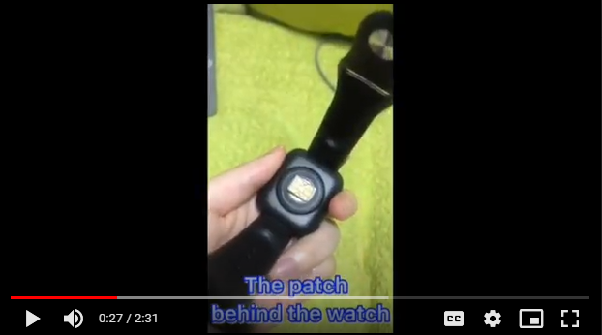

- The Kidface group developed a prototype for their “Emotion” board game that is designed to address potential mental health issues of Hong Kong students
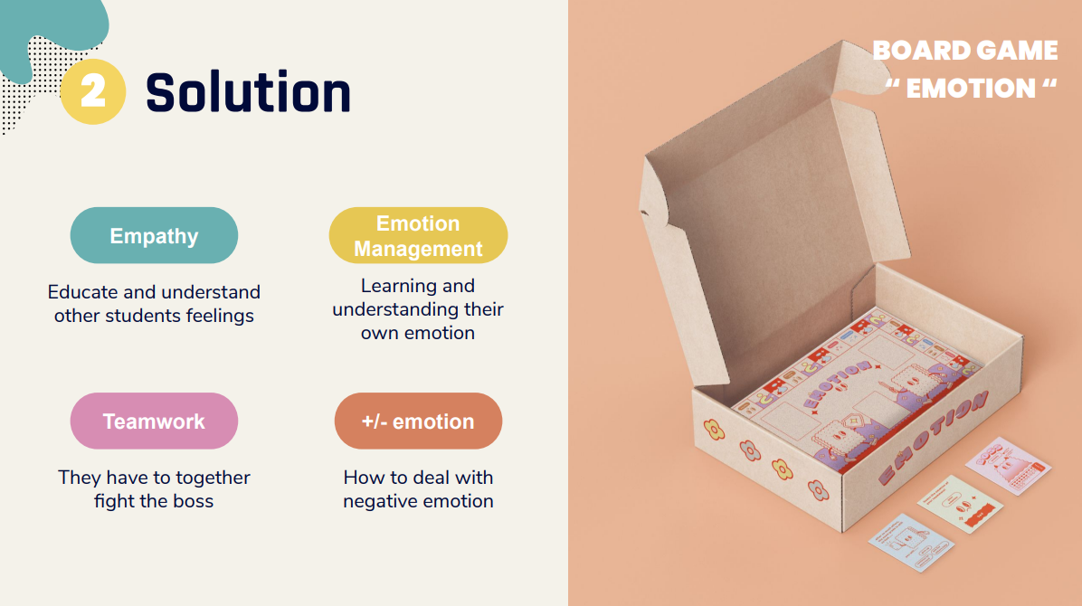
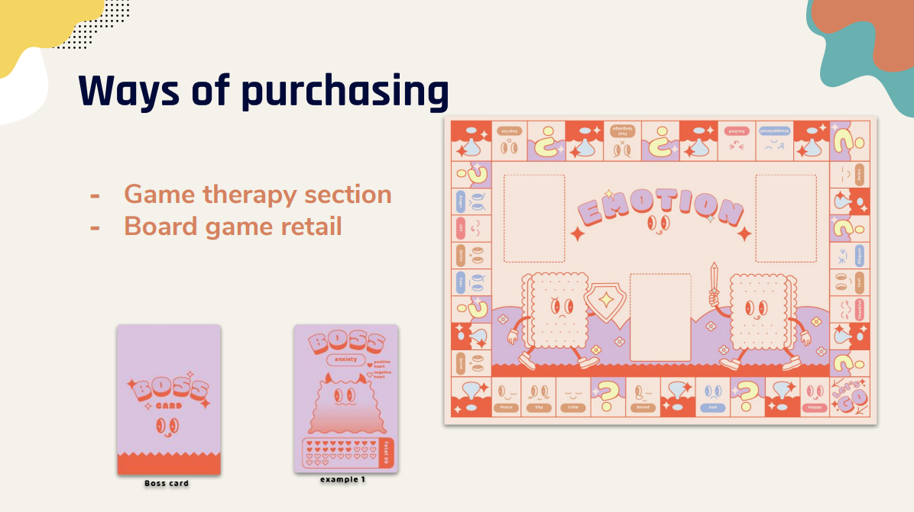

Other observations under COVID-19
The HK$100 Prototype has been used in three cohorts of GTCU 2036 students in AY2020-21 (Sem 1, Sem 2, and Summer), which is a period at HKBU where a high proportion of students has opted to attend online classes instead of face-to-face sessions due to Covid-19. In this environment, students faced significant challenges in terms of interacting with each other, with the course instructor, and their target users and stakeholders. Students had to take advantage of online communication tools and platforms to mitigate some of these challenges.

Reference
Razzouk, R., Shute, V. (2012). What Is Design Thinking and Why Is It Important? Review of Educational Research, 82(3), 330-348.

- Authentic Assessment Task for Teaching Orthopedics and Traumatology of Chinese Medicine and Tui Na, contributed by Mr. Chun Hoi CHEUNG and Professor Feng TU, School of Chinese Medicine, Hong Kong Baptist University.

Context
The concerned course, Orthopaedics and Traumatology of Chinese Medicine and Tui Na, aims to equip students with the knowledge and skills in Orthopaedics and Traumatology of Chinese Medicine and Tui Na for fulfilling the relevant requirements in Chinese Medicine Practitioners Licensing Examination, clinical practices and life-long learning. It is spread over two semesters and supported by two consecutive laboratory courses. Given its professional, practical and clinical nature, authentic assessment approach has been constantly adopted.

Traditional assessment: essay assignments

Authentic Task adopted: Service-Learning through conducting medical inquiry and advice for elders in need (20% of the whole course grade)

Scenario:
The team has incorporated Service-Learning into the official curriculum, which was previously held as volunteer work instead of a ‘service’ and ‘learning’. In the Spring Semester of 2021, the teaching team invited Hong Kong Sheng Kung Hui (Anglican Church) to establish the ‘Ease the Pain Workshop’ involving 28 Fourth Year Bachelor of Chinese Medicine students and six patients recruited in the Kowloon district.
The six patients recruited by the community partner are the elders aged from 72 to 93 with chronic pain issues and financial needs. They live in old public housing estates that do not have elevators on each floor. As a result, some of them need to walk downstairs or upstairs whenever they need to go out. Due to the pain problems, mobility has been difficult for them that significantly lowers their quality of life.

Tasks:
The activity consists of three sessions totalling nine hours, which took place during classes and online. Students were divided into six groups and were required to communicate with the patient assigned to their respective group.
- The 1st Session: A briefing session was conducted to equip students with interviewing skills and guiding questions. A 1.5-hour medical inquiry and interview was conducted about patient’s background and how the pain problem affects their lives, etc.
- The 2nd Session: Since it was the pandemic time, the students were required to design easy and suitable exercise to relieve the pain and increase mobility.
The patients were asked to do the exercise every day as instructed by students.
- The 3rd Session: Follow-up interviews were conducted for students to check if the patients have improvements, provide general health advice that help with their conditions, such as prevention of fall risk, food therapies.

Justification
One of the Course Intended Learning Outcomes is to help students develop generic attributes of a Chinese Medicine (CM) doctor, which can never be taught in the textbooks. The course design team collaborated with community partners to recruit patients who suffer in real life through provision of Service-Learning by students. The participating Year 4 students had minimal experience of interacting with real patients. Students often focus on learning textbook knowledge and specific treatments. Nevertheless, they somehow neglect the fact that real-life diseases are often complicated, and a CM doctor should also pay attention to how the patient’s personal background, such as emotions or living environment might affect or even cause diseases.
Since most students did not have experience of handling real patients and chronic pain diseases, the Service-Learning provided an excellent opportunity for them to practice their skills on medical inquiry and problem-solving skills, as the students could not perform the actual treatments, they have learned in class for use on the patients due to the ongoing pandemic.
Though there were teachers supervising the Service-Learning process, the students took initiative to design and decide the exercises and health advice for their patients. The teachers would only discuss matters with the students when they have questions regarding the diseases. Thus, the students had total supported autonomy in their service provision.

Grading: What you need to do
- You should conduct pre- and post-questionnaire-based survey tests for self-evaluation (5% out of 20% for Service-Learning), by adopting the Common Outcome Measurement (COM) model designed by the Higher Education Service-Learning Network. This means you must complete 36 questions before and after the Service-Learning, so that comparison of pre- and post- results can be made once data has been collected.
- You should develop your E-Portfolio to include a reflection on the Service-Learning and establishment of a medical record for the patient (7.5% of the total course grade).
Focus Group Interviews (5% out of 20% for Service-Learning) will be undertaken to collect opinions from community partners, students and patients on the Service-Learning and student performance. Once the data has been collected and transcribed, your improvements will be gauged in areas including communication skills, civic responsibility and academic knowledge.

Commentary: Student Learning Experience and Achievement
The pre- and post- survey shows that the students improved in nine domains – confidence, communication skills, problem-solving skills, civic engagement, team skills, self-reflection, knowledge application, caring for others and intercultural competence, in which student improvement in confidence, communication skills and problem-solving skills was found marked.
In the focus group interviews and debriefing session, some students reflected that the Service-Learning helped them understand the difficulties involved in becoming a CM doctor and motivated them to learn better. Although the elders recruited were very patient in answering all of their questions, some students found hard to get to the bottom of the chief complaint of their health conditions. Through the Service-Learning, they learned how to communicate with elders and real patients, that they would need to pay attention to their emotions. The service recipients (elders) commended that our students were caring, hard-working and patient in diagnosing their symptoms, and their suggested exercises helped relieve their health condition. Likewise, the community partner found that our students had done their best in serving the elders under pandemic constraints.

- Authentic Assessment Task for Multimedia Journalism, contributed by Mr. Dean C.K. COX, Department of Journalism, Hong Kong Baptist University.

Typical face-to-face authentic assignments
Graduate course, Multimedia Journalism, is intensively practical and heavily relies on the use of professional software (e.g., Adobe CC suite with Bridge, Photoshop, Audition and Premiere), hardware (e.g., Zoom H4n digital audio recorders, Canon DSLR still and video cameras with mics, tripods, etc.), as well as the computer labs and equipment on campus. Before the COVID-19 pandemic, the concerned course adopted three assessments, including
- Three short quizzes on multimedia stories (10%) with questions coming from a collection of professional multimedia news stories and class lectures;
- individual assignment of photo (30%) story/essay; and
- group projects of audio (30%) and video (30%) stories.
By definition, the second and third components were typical authentic assessments, conducting real-world interviews and journalistic work around Hong Kong and on-campus in labs editing and producing the multimedia news stories.

Strengthened by a digital community of journalism learners
Context
Since 90% of students in this course come from mainland China, when the pandemic broke out, it became difficult to conduct the original assessments. As a solution, the group assignments were replaced with individual ones. The instructor explored adopting alternative equipment (e.g., mobile devices, home laptops and desktop computers, and personal hardware) and free or open-source software to provide more flexibility to students’ learning and fulfilling assignments. The Department of Journalism also paid for a one-year account for each student from this course to use Adobe CC 2020 suite for home use. Padlets, a real-time collaborative web platform for content development and organisation, was used to share information, including stories on journalism ethics, multimedia news stories, and multimedia resources, and to turn in completed assignments.

Revised Tasks to cope with pandemic conditions
The Course Intended Learning Outcomes of this course include:
- Create a photo essay, an audio story, and a video story for which you can find, report, edit, and produce;
- Explain the differences, strengths, and weaknesses in linear digital story-telling techniques;
- Perform the basic skills required to use digital reporting hardware and software used in the modern newsroom; and
- Reflect on opportunities for interaction between user, content, and creator in multimedia news presentation.

By virtue of this online community of journalism learning, students worked collaboratively on the tasks below:
- Task 1: Go shoot – Composition and Portrait (formative assessments)
Every student was required to complete two sub-assignments of photography. One was taking photos of what happened in their daily life by using different compositional techniques. Then students were required to upload their works to the Padlets board, add their name, and identify/analyse the compositional techniques they had applied. The other sub-assignment was taking formal and informal portrait photos alongside doing interviews about their subject’s backgrounds, finding out something special about the person they shot. Similarly, students also shared their works on Padlets. Other classmates and the course instructor offered feedback on every works, and the student photographer responded accordingly.

- Task 2: Photo and Audio Storytelling (summative assessments)
Throughout the semester, students delivered their photo stories via Padlets by adding headings and captions. They were required to make the photos downloadable so that the instructor could ensure the photos were recently taken from real-life settings. Another summative assignment was an audio story. Students needed to present edited, first-person narrative audio stories of their subject, along with background information, a notable quote, and informal and formal portrait photographs of their interview subject. This assignment was also delivered by using Padlet.

- Scaffolding
In addition, five formative activities, which were not counted towards the total grade, were conducted to facilitate students’ learning progress and continuous reflection (CILO4).
  - A virtual map on Padlet was used to invite students to share their locations and personal stories, identifying where students were joining the Zoom classes during the beginning of the semester. In this way, students could meet each other away from Hong Kong if they happened to be in the same city.
  - An in-class brainstorming session using Padlet for students to express how they defined ‘“journalism”’ and what they considered to be ‘“multimedia storytelling elements.”’ In this way, students could anonymously write whatever they wanted and afterwards we could discuss their collaborative entries.
  - A bi-weekly online discussion named Wow! What? were conducted. Every student was required to post what they found out new from their daily life as “wow moment” and mark down the “what moment,” that is, the questions they would like to better understand after every two weeks’ lectures. The instructor answered these questions, and students sometimes posted follow-up responses.
  - A Kaffeeklatsch, a twice-a-week informal Zoom gathering of four to five students for one hour, was organised. Students could bring any topics related to the assignments and lectures and the journalism profession in practice for discussion.
  - EdPuzzle was used for students to better critique and analyze non-fiction narrative short documentary movies.

Justification
It has been proved that publishing experience beyond the university plays an effective and valuable way in journalism education at the tertiary level (Fulton et al., 2021). Intentionally integrating this kind of authentic experience into assessments helps boost students’ confidence as future journalism professionals, and more importantly, enhances their personal publishing profile cumulatively. Simulating the real-life media environment, which involves various feedback from and interaction with different stakeholders, the settings of an online community of journalism learners provide students with a development process of multiple stages, opportunities to continuously optimising their works, and a sense of achievement via publishing. This has particular significance under the constraints of social distancing in encouraging students’ career aspirations and graduate employability.

Grading methods
The instructor graded all the assignments, which were subjective and required a lot of feedback. For each assignment, in addition to a score, he would typically provide half a page to a full page of feedback. For the Moodle-based quizzes, which were automatically graded, individualized feedback for each question was provided as well.

Sample Assignments
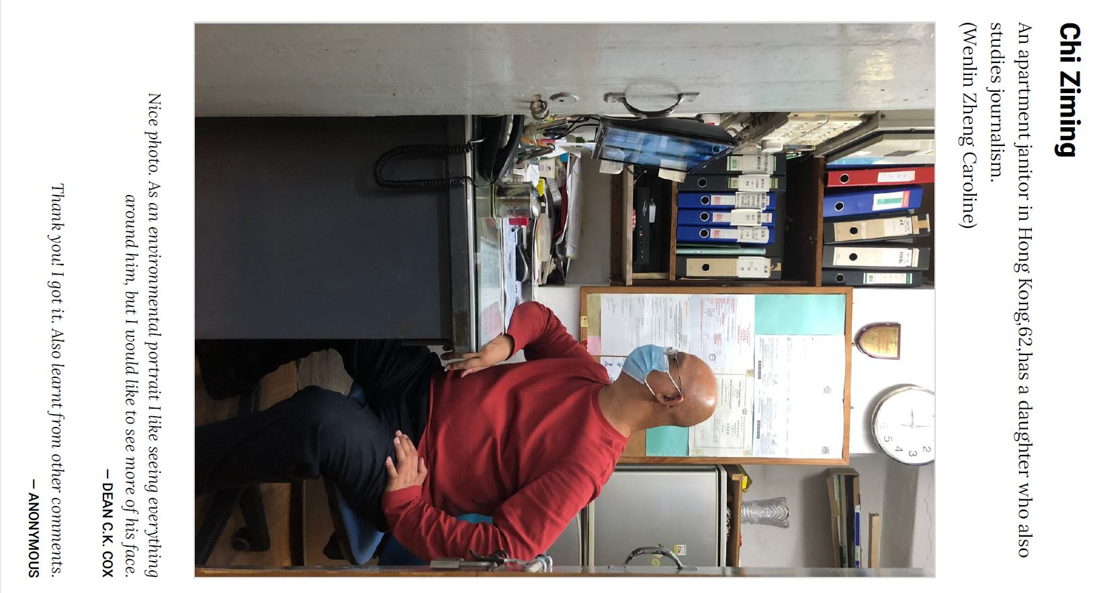
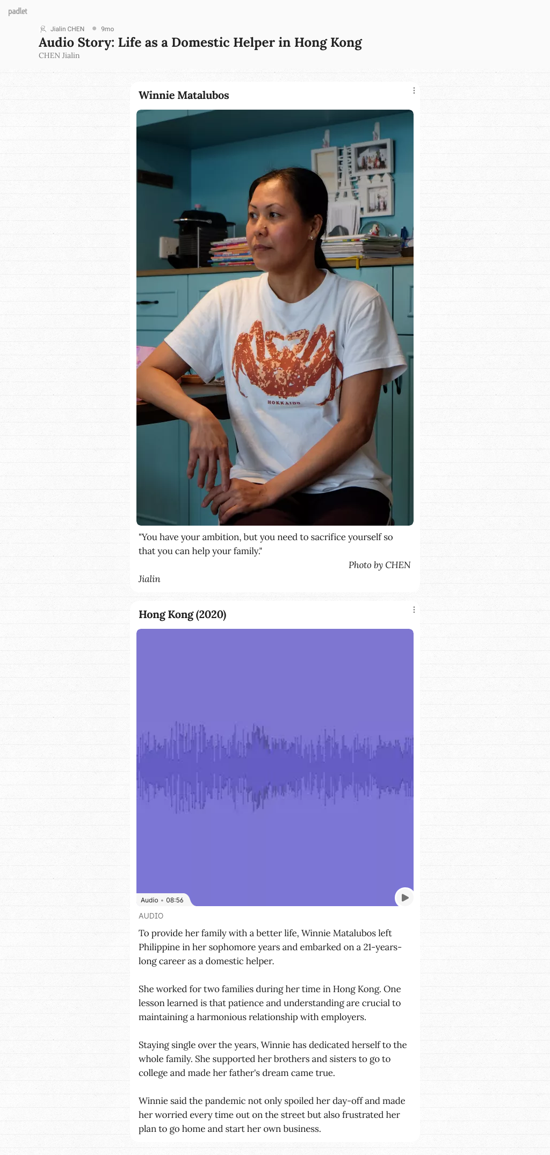
Go shooting – Portrait Audio Story

Reference
Fulton, J., Scott, P., Biggins, F., & Koutsoukos, C. (2021). Fear or favor: Student views on embedding authentic assessments in journalism education. International Journal of Work-Integrated Learning, 22(1), 57–71.

- Authentic assessment in Modern Musical Theatre & Opera, contributed by Dr Eugene Alexander BIRMAN, Department of Music, Hong Kong Baptist University.

For the course of Western Music History Topic One, targeting undergraduate students at the Department of Music at Hong Kong Baptist University (HKBU), I have leveraged the use of authentic assessment to engage students in the active learning process throughout the course.

Course Intended Learning Outcomes (CILOs):
- Demonstrate a broad familiarity with important musical works and genres, and cogently discuss them as autonomous musical creations of their composers;
- Show and articulate an understanding of the social settings in which different musical works and genres were created, and both the musical and social issues which they continue raise today;
- Express in detail a critical approach to the study of selected genres in Western music, their development and performance;
- Conduct musical and textual analyses of works, discussing and evaluating them in their musical historic position;
- Present ideas and points of view of musical topics clearly and effectively in writing and in speech; and
- Articulate and justify their personal opinions on performers, performances, and repertory.

Introduction of the authentic assessment
I decided that, through students’ direct engagement with cultural and musical leaders in the field, CILOs 4-6, targeting clear, effective, and original expression and analysis of musical works as well as an understanding of their historical and contemporary contexts, would be fulfilled in novel ways. The development of a creative project ran through the duration of the course, replacing both the final examination and essay assignments, with input from myself, guest lecturers, and student helpers, would add a real-life, practical dimension to student learning. While memorization and retention of dates and historical material are important, I believe a focus on doing real analysis, public speaking and discussion through engagement and Q&A with the guests over Zoom, and collaborative work, as CILO 5 specifically details, is particularly rewarding for students and generates valuable skills for post-graduate study or practical work.

Traditional Assessments to be replaced
A final examination addressing all the above CILOs which accounted for 50% of the final course mark was replaced. The examination aimed to assess major learning outcomes, in particular, students’ familiarity with, and ability to discuss with relevance the works studied in the course; their ability to write critically about a musical topic; and apply skills and knowledge acquired in comparative situations.
As well as this, an essay (1500 words) which was used to assess students on their abilities to search and evaluate material on their chosen topic, and the cogency of the writing and presentation skills, was also be replaced.

Justification of putting in place the authentic assessment
The pandemic has, of course, upended pre-existing assessment methods anyway as methods such as proctored exams, giving presentations, etc. have had to move online or even offline with the proviso that students are to be trusted not to plagiarize or cheat while doing so. The movement to explore alternative methods of course existed far earlier than that, but the pandemic gave far more urgency to this while also allowing new methods of course delivery to inform the new assessment methods. Therefore, the integration of peer assessment, collaborative assessment by the guest lecturers via VTL, and oral presentations instead of rote memorization and examination, is a product both of the new pandemic teaching reality but also simply of the aims of this class to encourage students to work together and receive many rounds of feedback from different levels of mentors along the way.

About the adopted authentic assessment
Eight of the twelve weekly lectures commenced with a 20–30-minute Zoom presentation by a leading practitioner in the field of musical theatre; all perspectives would be offered, from leaders of major institutions funding opera to stage directors, lighting designers, conductors, and of course, singers. A perspective from an administrator in music education at the Bayerische Theaterakademie August Everding, the leading opera preparatory program in Europe, was also be offered to give students an idea of what to expect should they choose to further pursue their studies.
Following the presentation students were asked to come with prepared questions (pre-assigned on a rotating list) for a 20–30-minute Q&A period with the guest on Zoom. I moderate both the presentation and the Q&A period, so that the guest’s lecture is of pertinent use to the students and so that the questions elicit a proper discussion (instead of being closed-ended). On a weekly basis, students report their reactions and feedback to the guest speakers via the Moodle Journal function.
Students’ performance in the course are graded via semester-long ‘cumulative’ assessment with inputs from guest lecturers and a Research Postgraduate student helper.

Conclusion
The pandemic has upended practices which had become automatically ingrained into the assessment protocol – regular assessment geared towards rote memorization, and a teacher-student hierarchy. Inspired by mixed-mode teaching, the above course explored the possibility of various kinds of input and assessment at different stages along a student’s progress through the semester - guest lecturers, a Research Postgraduate student, and peer assessment were all employed to help students craft more persuasive and original projects. All assignments were collaborative, to encourage students to work collaboratively also in their professional lives. Thereby, Authentic Assessment, as demonstrated also in the in-class student survey on the curriculum, assessment, and deliverables:
http://drive.google.com/file/d/1y4VOV75nk7tt3XXn581Hbj7cSKECpbsR/view?usp=sharing , was the only possible way to create a reasonable framework for ensuring that the Course Intended Learning Outcomes would be achieved – in fact, more so, because the students received real-world mentorship and input from outstanding professionals in their field.

- Authentic Assessment Task for Teaching Forensic Analytical Chemistry, contributed by Dr. Gray HO, Department of Chemistry, Hong Kong Baptist University.

Assignments:
The course concerned, Forensic Analytical Chemistry, has been offered since AY2017/18. It aims to provide students with general knowledge on the application of analytical chemistry techniques in forensic science. Given its practical nature, an authentic assessment approach/simulation has been adopted from the outset as a traditional essay type assignment would not be appropriate.

Authentic Task adopted:
Group Project: Crime Scene Investigation of a Simulated Crime Scene.

Context:
All students are expected to assume the role of Sherlock Holmes, in which they are required to solve a range of real-life problems in forensic analysis under a simulated crime scene setting.
A simulated crime case (creating real-world relevance) is set up in a classroom to induce a sense of suspense and intrigue, while at the same time helping students hone their skills in identifying chemicals, powder, pills, hair and fur, and fluids left behind in the crime scene (an ill-defined problem that is open to multiple interpretations). They might have to examine the red stains smeared on the doors, and then the colourless fluid that trickled down from the table to the floor to crosscheck their initial conclusions (sustained investigation requiring investment of time and resources). Students are required to follow the following investigation steps:
- What analytical requirements and forensic analysis are required to examine these traces of criminal evidence? What kinds of colour tests are needed?
- Which microscopic tests help identify the morphological features of the evidence?
- What procedure is used to reveal any latent fingerprint on the surface of evidence?
- Based on the evidence and their analytical work (using the simple scientific principle of “follow the data”), can students conclude if this is a case of suicide or murder?

Scenario
Assume that you work as a forensic chemist in the Forensic Science Division of Government Laboratory. The job duties include crime scene investigation, analysis of physical evidence, and crime scene reconstruction.

Tasks:
- Crime Scene Investigation: 15 minutes will be given to each group to process the crime scene. The investigation should include, but not limit to, recording the scene by photography, sketches, and/or note taking, and searching for physical evidence. Real-life problems require real-life skills. Since students step into the shoes of detectives, they have to interact with their peers (collaboration/teamwork) and reflect on the process (metacognition/reflection individually and as a team).
- Analysis of Physical Evidence: 15 minutes will be given to each group to report the physical evidence found, and to propose the respective analysis for identification and comparison. Results of the analysis will then be given.
- Crime Scene Reconstruction: Based on the crime scene investigation and analysis of physical evidence, crime scene reconstruction should be achieved. The presentation should include, but not limited to, the physical evidence found, the respective analysis for identification and comparison, and the conclusion of the criminal case.

Justification
Simulation-based assessment mimics a complex real-life situation to engage students in practical tasks and motivate them to try different alternatives to solve problems. Though simulation does not entirely represent the complexity of the reality, it fits this course because real-life situations do not always provide practice opportunities (e.g., being a detective), and practice in real-life situations without systematic guidance can be overtaxing for students and come with risks and ethical issues (e.g., a crime scene) (Chernikova, et al, 2020).

Grading Methods
For element 2, marks are given to the whole group based on the number of physical evidence found and the relevance of the respective proposed analysis.
For element 3, marks are given to the whole group based on three aspects of communication, presentation materials, and questions and answers.
Finally, the marks of the group project will contribute 30% to the overall assessment.

Student Learning Experience and Achievement
Students found this authentic assessment – criminal scene investigation “inspiring,” which provided them with a good chance “to experience the work of forensic scientists” and allowed them to “discover the difficulties which may have during the crime scene investigation.” Students acquired “hands-on experience on how forensic scientists work in the real world” and are able to “apply the knowledge learnt in lectures to practical work.”
The instructor observed that this authentic assessment enabled students to clearly exhibit their logical deduction, scientific reasoning, and argument defensive as they built the case that supported their conclusions. Some groups took further advantage of the CSI settings and performed role-play for the crime scene reconstruction, assuming the roles of the murderer and victims and acting out how traces were being left behind at the scene (multiple interpretations and outcomes).

References
Chernikova, O., Heitzmann, N., Stadler, M., Holzberger, D., Seidel, T., & Fischer, F. (2020). Simulation-based learning in higher education: a meta-analysis. Review of Educational Research, 90(4), 499-541.

- Authentic Assessment Task for Teaching Medical Ethics, contributed by Dr Kevin YUE, School of Chinese Medicine, Hong Kong Baptist University.

Background
Though knowledge and competencies are the primary goals of formal medical training, an understanding of professional values and ethical conduct is essential for fostering the development of a good doctor (AlMahmoud, et al, 2017). The course concerned, Medical Ethics, primarily aims to equip students with basic ethical concepts, applying them to ethical decisions in clinical settings and reflecting upon important medical ethical issues. The course has been substantially revamped in terms of course intended learning outcomes, teaching and learning activities and assessment methods.

Traditional assignments:
Mid-term and final examinations were completely replaced by summative assessment in order to better motivate students. Authentic assessment methods consisting of class role-play, class case study, group debate and written essay, are all based on professional and real-life scenarios. Explicitly, this retrofit not only gives authentic assessment methods more emphasis, but also aligns teaching and learning activities and assessment methods.

Context
Medical and health care practitioners usually deal with a great variety of perplexing ethical problems and dilemma, such as patient rights and dignity, meaningless life-sustaining care, communication dynamics with peers and patients, patient advocacy, sudden death in accident and emergency room, organ donation and end-of-life treatment limitation (Sofaer, 1995; Kim & Park, 2019; Almoallem, et al, 2020). Therefore, students are provided with a series of controversial real scenarios for them to help them understand different and even conflicting perspectives and present their judgements through the forms of discussion, debate, role-play and written analysis.

Authentic Tasks adopted
The authentic assessment methods adopted below are all widely applied in medical education (Kim & Park, 2019; Souza & Vaswani, 2020).
- Class Role Play (30%) – students respond to medical ethical questions in terms of role play format.
- Class Case Study (10%) – students discuss in class responding to the case study questions.
- Group Debate (30%) – students discuss in groups and discuss on medical ethics issue in debate format.
- Written Essay (30%) – students should complete their individual essay report about analysis of medical ethical issues.

I would like to particularly share our approach to adopting class role-play and group debate. Regarding the class role-play, two widely-disputable scenarios – ‘Legitimate Euthanasia’ and ‘Organ Donation’ were offered to students for acting on different roles. By using ‘Organ Donation’ as an example, a real Hong Kong case was selected: it described the process of how the family members of a 13-year old girl who died by illness initially resisted organ donation, struggled to deal with the persuasive arguments of medical and nursing staff, and finally decided to donate her liver to the patients in emergency need. Eventually, their benevolent behaviour saved the lives of four patients. Students played the roles of family members of the deceased, medical and nursing staff, beneficiary and his family members, so that they could see the situation from different perspectives and develop their empathy for patients. Indeed, students played their respective roles vividly and made the learning atmosphere stimulating. With respect to group debate, the controversial topics cover ‘pregnant women are required to go for antenatal check-ups to avoid the birth of infants with Down's Syndrome’, ‘Hong Kong SAR Government should enact a law to prohibit suicides from receiving first aid’ and ‘Hong Kong SAR Government should enact a law for mandatory HPV vaccination for all girls at the fifth grade of primary schools’. The group debates were conducted under a systematic process, consisting of first proposition, first opposition, second proposition, second opposition, proposition reply and opposition reply, with each element lasting five minutes.

Justification
Role-play is widely used in medical education to impart knowledge, attitudes and skills in students through dealing with realistic, serious complex and ambivalent professional situations (Nestel & Tierney, 2007; Manzoor, et al, 2012). Students’ participation in role-play has been proved to improve patient care in a clinical capacity (Rasasingam, et al, 2017). Role play also seems to be favoured by students and instructors alike. For teachers, role play can cement bonds between themselves and students. Students welcome role-playing because this activity brings variation, movement, and normally, simulated real-world experience into the classroom (Manzoor, et al, 2012). Debate is also found an effective learning method, as it requires students to take a stance on a given topic, explore and gain understanding of alternative viewpoints, make judgments according to the professional code of conduct and take ownership of values necessary to defend their positions, and persuade students with opposite views. By experiencing such complex reasoning processing, students are able develop their communication, critical thinking, and argumentation competencies (Kim and Park, 2019).

The role play, essay and case study are assessed using rubrics. The group debate (30%) is assessed by the following criteria:
- Content: the content should be objective and comprehensive and demonstrate sufficient application of knowledge learnt at classroom.
- Presentation: the presentation should give sufficient information, appropriate references, clear and definite standpoint, distinct logic and convincing analysis.
- Expression: expression should be fluent and clear, demonstrate seamless teamwork and time management.
- Enquiry and defense: students should ask questions actively; questions should be specific to the topic and have depth; answers should have rationale and evidence with explicit key points. The whole process should be polite.

Student Learning Experiences
Comparison of the course results between AY2019-20 and AY2020-21 shows that student learning experiences have been explicitly enhanced at both Quality of Teaching (mean score range: from 4.50 to 4.88 in AY2020-21 versus from 4.00 to 4.60 in AY2019-20) and Learning Reflections (mean score range: from 4.38 to 4.75 in AY2020-21 versus from 4.00 to 4.40 in AY2019-20). In regard to the authentic assessment methods adopted, one student particularly welcomed the removal of examination as there are no right and no wrong answers in ethics and another student commended on the role play.

Conclusion
All authentic assessment methods adopted in this course enable students to examine professional and real-life issues by utilising values, facts, and logic to decide what the best course of action should be in what are often highly challenging and contested areas.

References
- AlMahmoud, T., Hashim, M. J., Elzubeir, M. A., & Branicki, F. (2017). Ethics teaching in a medical education environment: preferences for diversity of learning and assessment methods. Medical education online, 22(1), 1328257.
- Almoallem, A. M., Almudayfir, M. A., Al-Jahdail, Y. H., Ahmed, A. E., Al-Shaikh, A., Baharoon, S., ... & Al-Jahdali, H. (2020). Top Ethical Issues Concerning Healthcare Providers Working in Saudi Arabia. Journal of Epidemiology and Global Health, 10(2), 143.
- Nestel, D., & Tierney, T. (2007). Role-play for medical students learning about communication: guidelines for maximising benefits. BMC medical education, 7(1), 1-9.
- Kim, W. J., & Park, J. H. (2019). The effects of debate-based ethics education on the moral sensitivity and judgment of nursing students: A quasi-experimental study. Nurse education today, 83, 104200.
- Knowles, M. S., Holton, E., & Swanson, R. (2005). The adult learner: the definitive classic in adult education and human resource development (6th). Burlington, MA: Elsevier.
- Manzoor, I., Mukhtar, F., & Hashmi, N. R. (2012). Medical students’ perspective about role-plays as a teaching strategy in community medicine. J Coll Physicians Surg Pak, 22(4), 222-5.
- McIlvried, D. E., Prucka, S. K., Herbst, M., Barger, C., & Robin, N. H. (2008). The use of role-play to enhance medical student understanding of genetic counselling. Genetics in Medicine, 10(10), 739-744.
- Nestel, D., & Tierney, T. (2007). Role-play for medical students learning about communication: guidelines for maximising benefits. BMC medical education, 7(1), 1-9.
- Rasasingam, D., Kerry, G., Gokani, S., Zargaran, A., Ash, J., & Mittal, A. (2017). Being a patient: a medical student’s perspective. Advances in medical education and practice, 8, 163.
- Sofaer, B. (1995). Enhancing humanistic skills: an experiential approach to learning about ethical issues in health care. Journal of medical ethics, 21(1), 31-34.
- Souza, A. D., & Vaswani, V. (2020). Diversity in approach to teaching and assessing ethics education for medical undergraduates: A scoping review. Annals of Medicine and Surgery, 56, 178-185.

- Authentic Assessment Task for Visual Arts Practice, contributed by Mr. Peter BENZ, Academy of Visual Arts, Hong Kong Baptist University

Face-to-face authentic and performance-driven assessments:
All courses in the Academy of Visual Arts (AVA) of Hong Kong Baptist University (HKBU) currently adopt alternative, non-examination-based assessments as a reflection of the nature of the visual arts as a practical ‘making’ discipline. Accordingly, the vast majority of AVA courses require the submission of creative works for assessment, which students then need to defend in a live critique.
The Course Intended Learning Outcomes of the course concerned are:
- apply a selection of fundamental analogue and digital skills and techniques to creative projects;
- apply critical thinking and creative problem solving in their making of creative projects;
- independently research appropriate information and means relevant to their personal work;
- analyse creative projects and practices for meaningful insights;
- effectively communicate creative ideas with appropriate analogue and digital means; and
- adhere to standards of professional practice and ethos.

In normal years, students of the course concerned, Visual Arts Practice, would usually produce two distinct practical pieces of work, an individual ‘“picture book”’ – i.e., a self-produced hardcopy of a personally composed story told by means of integrated images and text – as well as a small sculptural work made of clay. The clay sculpture would generally be based on some aspect of the picture book: for example, it could be a three-dimensional articulation of the picture book’s main character. Instructors would organise a huge bonfire with BBQ etc. on campus in the last week of class in which the clay work of all students would be fired. For the last five or six years, those bonfire events regularly turned into very popular end-of-term celebrations of students’ achievements in their first university term.

Replaced by remote, authentic assessments:
Context
During the COVID-19, this common assessment approach in the field of visual arts turned out to be reasonably adaptable to online/hybrid ones, despite how individual project details may have produced other results under different circumstances. In addition to these, more generic considerations on assessment, the course’s teaching team felt it appropriate during the special COVID-19 situation to consider students’ more general context, i.e., their staying-home conditions, mental state, etc. Also, online classes tended especially to suppress the participation of less extroverted students or students who couldn’t actively join for external circumstances.

Tasks
The students work on the following two tasks as the major authentic assessments:
- Workshop Projects: 50% (Aligned to CILO 1, 2)
Students are required to finish two small-scale projects in two different media to explore various skills and approaches being introduced. One project will be 2D and may be completed in digital or analogue form, while the second will be 3D and of analogue nature. Instead of working on each of these projects for five to six weeks consecutively, the course was broken down into five smaller modules: students worked on each for two weeks only, then received formative oral feedback (‘critique’) before starting the next module. For the two final project submissions – which were the only instances formally assessed– students assembled their five (potentially revised) earlier outputs into two respective aggregate submissions: one of them again a “picture book” (though of less coherent nature than in previous years) and an “exhibition-in-a-box” – a shoe-box-sized curated collection of their various smaller attempts in clay.
For the 3D clay project, the instructors organised a ‘clay take away’ for students to pick up a lump of clay as well as some basic tools: where students couldn’t come to campus, materials were sent by courier. In extreme cases (one student resided in Mexico for part of the course) demonstration videos were provided to produce paper clay as an alternative medium.

- Documentations: 20% (Aligned to CILO 3, 4, 5)
Students are required to document their learning activities and creative process in two formal process books, including images, sketches, and reflective texts submitted at the end of each of the respective workshop projects. In this particular year, both documentations were due after the end of the term on the same date. Therefore, students could choose to submit only one set of documentation with two distinct chapters for the respective projects as digital copies only.

Scaffolding
Once a week, each student was expected to upload to a Google Drive one image representing their experiences of the last week with a short personal note for sharing with the whole class. The ‘postcard’ as such was not assessed in any way for content or design. However, participation in the activity did count towards class participation; it also allowed the teachers to keep an overview of students’ engagement and mood throughout the term.

Justification
In the course concerned, the assessment methods must be authentic and performance-driven per se, as it focuses on initially introducing students to a selected set of practical 2D and 3D skills that enable them to initiate their personal creative production and develop a sense of sustainable personal studio practice. We found that any assessment methods demanding fixed or memorized responses are not compatible with our intentions. Instead, as is common practice in tertiary arts education, AVA uses performance-based assessment, i.e., assessment methods and techniques requiring students to apply their knowledge and skills to create a demonstration or product reflecting the essence of the content matter being assessed. Such approaches are more appropriate and relevant for the visual arts since they allow for creative behaviour and divergent thinking (Boughton, 2013; Assessment Learning Network (ALN), The Michigan Assessment Consortium, 2019).
In the academic year 2020/21, this approach didn’t seem feasible. While the COVID-19 situation was calming down at the beginning of the term, the situation remained very volatile. It was essentially unpredictable concerning whether the term would be conducted online or face-to-face on campus. Therefore, the teaching team decided to adopt an ‘assemblage’ approach to the creative assessments. This approach allowed for easier appropriation of respective modules if the situation changed at short notice (e.g., if a student was sent to quarantine or if the campus was shut down for all students). By default, all classes were delivered in hybrid mode and recorded, so students could follow demonstrations physically or online, synchronously, and asynchronously. Students were also free to choose their drawing media for the picture book, thus accommodating respective available resources.

Grading methods
Formative assessments in the course concerned are generally conducted in some form of a public forum, generally by oral critiques: a student would (briefly) introduce their work and the considerations underpinning it, and classmates and teachers would respond with feedback. Such practice was generally maintained during COVID-19, although it partially took place via Zoom and could be extended by additional written feedback on Miro or Facebook. Students were expected to reflect on their learning and achievements as part of the required documentation to be submitted.
The course concerned is, by default, co-taught by three colleagues. For the assignments of Workshop Projects, three colleagues take charge of assessing one workshop assignment each, as aligned with their respective expertise. Regarding the Documentation, all colleagues co-grade students’ submissions. The overall summative assessment thus represents a joint overview of each individual student’s achievements in the course.

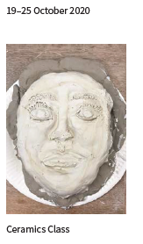
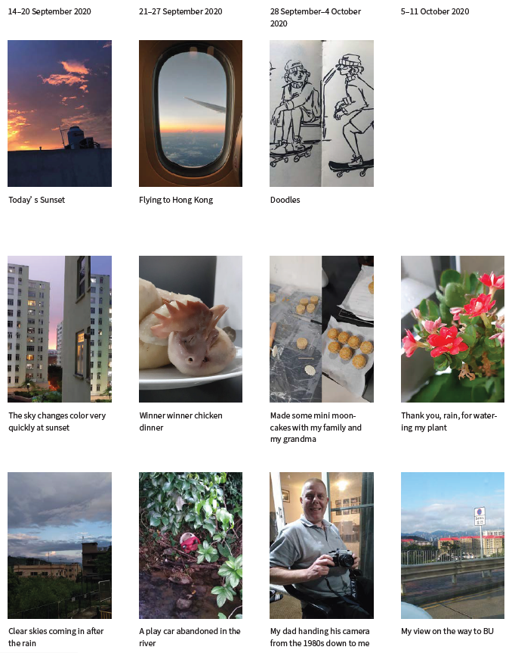
Sample weekly postcards

Other observations under COVID-19
We found several of the approaches adopted initially in response to the pandemic to indeed be rather fruitful. E.g., Miro as a new digital tool turned out to be very helpful but also worked well in creating a stronger sense of community and providing opportunities for engagement with students. After returning to normal teaching, we will certainly maintain some of these practices.

References
- Boughton, D. (2013). Assessment of performance in the visual arts: What, how, and why. From child art to visual language of youth: New models for assessment of learning and creation in art education, 119-142.
- Assessment Learning Network (ALN), The Michigan Assessment Consortium. (2019, January). Performance assessments in the visual arts classroom: How do they authentically show what students know and can do? (retrieved at http://www.michiganassessmentconsortium.org/wp-content/uploads/2019_January_PERFORMANCE_ASSESSMENTS_VISUAL_ARTS_CLASSROOM.pdf)

12. Authentic Assessment Task for English Language Teaching, contributed by Dr. Ricky LAM, Department of Education Studies, Hong Kong Baptist University

Traditional essay assignments:
Before the COVID-19 pandemic, the course concerned, Grammar for Teaching, adopted three conventional assessment components, including
- a language analysis task (written error detection and correction);
- two short essay questions relating to taught pedagogical grammar knowledge; and
- a term paper critiquing various grammar instructional approaches.

During the Pandemic this was replaced by an ePortfolio-assisted case study:
Context
The authentic assessment builds upon a real case scenario in which students are required to analyse and critique the effectiveness of one conventional approach to teaching grammar (i.e., conditional sentences) in a secondary school setting. Then, the students are asked to suggest an alternative instructional approach when teaching the same target grammar (conditional sentences, Type 2), target students (Grade 9, average-ability pupils), and in the same classroom situation (a Chinese-as-the-medium-of-instruction school).

The Course Intended Learning Outcomes
The CILOs of the course concerned include:
- discuss the nature of grammar and its place in the English language curriculum;
- analyse grammatical features that are problematic to Hong Kong learners;
- use metalanguage to discuss grammatical features;
- apply the grammatical knowledge introduced to reformulate learner errors; and
- critique approaches to grammar teaching.

Tasks
The students work on the following two tasks:
- Mini ePortfolio of teaching
As a group assignment, students are required to keep a mini ePortfolio to compile all flipped learning materials (e.g., weekly readings, discussion logs, questions, and notes), and using this as a basis, students individually are asked to address two out of four issues related to English as a Foreign Language (EFL) grammar instruction in the 11th week (total 13 weeks). Students could compile their artefacts via Moodle, Google Classroom, Google Drive, and other platforms they deemed appropriate.
- Case study essay
Students are required to write a term paper (a critique plus a recommendation) based upon the authentic case scenario wherein an EFL teacher taught four types of conditional sentences in a lockstep and top-down approach. The case scenario was extracted from my own research project data, so the assessment task was authentic.

Scaffolding
To facilitate students’ development of the ePortfolios, in weekly tutorials from the first to the tenth weeks, students read the prescribed article, discussed the questions, and compiled a brief written report for oral representations collaboratively. Instructor feedback on the oral representations was provided. Tutorials are purely formative, and no grade is involved. Students organised, reviewed, and reflected upon their written reports over time in preparation for writing up two grammar instruction issues for the summative assessment.

Justification
As a result of the pandemic, all assessment tasks were switched to the online or mixed mode. Also, 98% of the course participants (i.e. Chinese mainland students) were outside Hong Kong when the fourth wave of COVID-19 hit Hong Kong badly. Having learned about the benefits and positive impacts of authentic assessment on student learning, other than those which have to fulfil the Education Bureau teacher training requirements, I attempted to transform the assessment tasks into authentic assessments because:
- The authentic assessment tasks could better address the course intended learning outcomes because they require students to tap into their analytical and evaluative skills rather than demonstrating fundamental conceptual understanding only.
- The authentic assessment tasks reflect how students perform real-life tasks in teaching professions, such as compilation of teaching portfolios for professional development and job appraisals. The case scenario is able to align academic coursework with everyday classroom teaching practices seamlessly.
- Through these authentic assessment tasks, students are much more motivated to learn various grammar instruction approaches to address the two problematic classroom issues near the end of semester. In other words, the authentic assessments are engaging, learning-oriented, as well as realistic.

Grading methods
Grading of mini ePortfolios involves both formative and summative assessment. The instructor observed and provided students with formative feedback from the first week to the tenth week when they constructed their mini folios online and offline. In the eleventh week, the instructor summatively graded students’ commentaries on two self-selected grammar teaching issues, which were part of the students’ ePortfolio contents. Students’ term papers were graded summatively, but students were permitted to seek instructor’s initial comments on their early drafts.

Sample ePortfolio
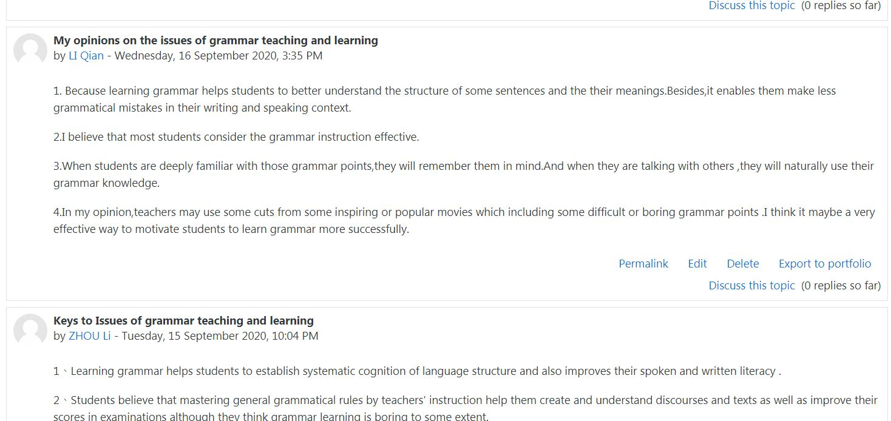
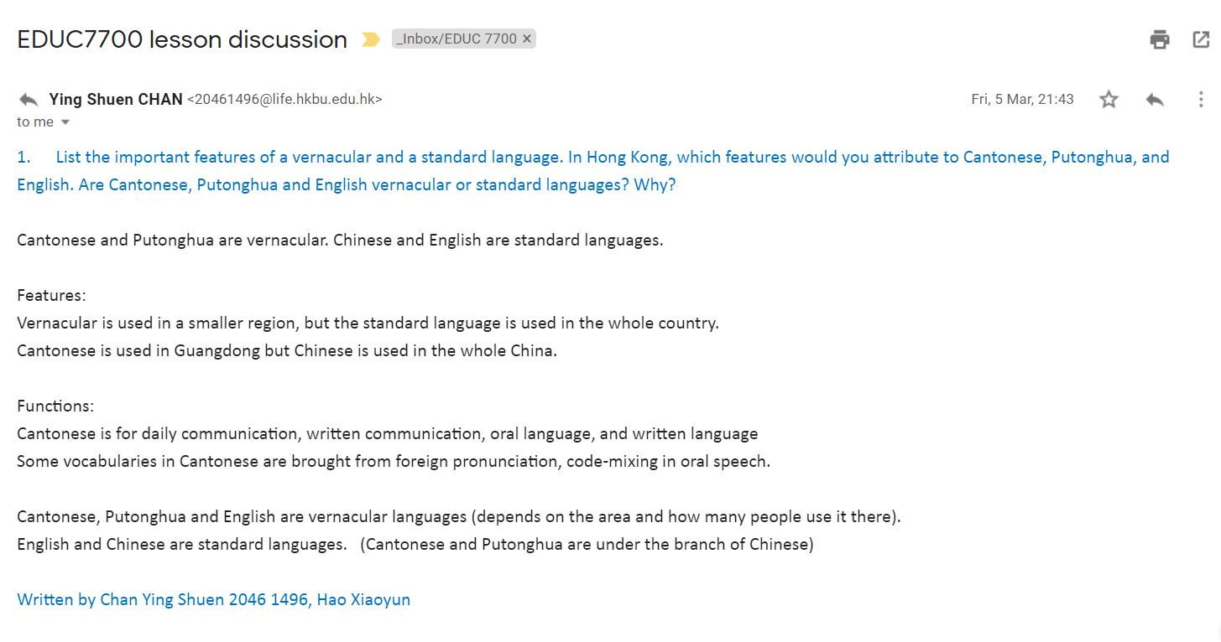
Reference
Clarke, J.L., & Boud, D. (2018). Refocusing portfolio assessment: curating for feedback and portrayal. Innovations in Education and Teaching International, 55(4), 479-486.

13. A case study on the adoption of authentic assessment in Music education, contributed by Dr. Camilo MENDEZ, Assistant Professor, Department of Music, Hong Kong Baptist University

Introduction
Over the past two years, the pandemic has presented a quintessential adaptive and transformative challenge to teachers and students around the world. There is no pre-configured playbook to guide the most appropriate responses in teaching and learning for different disciplines. But passionate and competent teachers, as I like to think I am, have swiftly designed responses to the pandemic in student.
To cope with the shift to online/mixed-mode teaching due to the pandemic in 2019/20, I have experimented with different types of authentic assessment in my courses. These include the use of playlists, postcards, audio essays, poster presentations, and weekly creative projects to assess student learning throughout the course period, and other interactive T&L activities (such as discussions, debates, tutorials, guide listening sessions, outdoor performances, telematic music performances and Hong Kong soundscapes) all of which count towards the final grade of the course participants. The adoption of such a rich platter of authentic assessment allowed me to make sure my students are learning theoretical concepts, while also guaranteeing that there are some forms of musical exchange crucial to widening students’ exposure to music worldwide.

Implementation of Authentic Assessment in the course of Special Topics in Music I – Music and/as Experimentation (MUSI4025)
In the course Special Topics in Music I – Music and/as Experimentation (MUSI4035) I have embraced the opportunity brought by the pandemic in adopting authentic assessment to facilitate student learning in a virtual context.
Course Aims and Objectives
This module aims to reflect both the research interests and professional competencies of the instructor as well as student interests. It is designed to present a more detailed approach to specific areas in Western music history than introductory or service courses. The goal is to lead students to an enhanced understanding and appreciation of a particular repertory, composer, genre, or other musical study area. The emphasis is more on depth, rather than breadth.

Course Intended Learning Outcomes (CILOs)
By the end of the course, students should be able to:
- Articulate a broad familiarity with important musical movements, works, research areas, methodologies, and/or genres, and cogently discuss them
- Express in detail a critical approach to the study of selected genres, movement, or research areas in Western music, their development and practice;
- Explain the larger settings in which musical works or research areas arose, and the musical, social, and/or other issues which they continue raise today;
- Conduct musical and textual analyses of musical works, discussing and evaluating them in their musical historic position;
- Present ideas and points of view of musical topics clearly and effectively in writing and in speech;
- Justify their personal opinions on performers, performances, repertory, or other musical topics.

In order to achieve the CILOs, I asked my students to attend an exhibition called “Stakes and Holders” by a renowned Los Angeles-based artist Shirley Tse at M+ Pavilion, a new cultural landmark in Hong Kong. Students then needed to produce an audio-visual essay on the relationship of Shirley’s installation at the exhibition and the experimental music practice, engaging students in the process of deeper learning. Other authentic assignments and projects in the course require students to attend online lectures hosted by Contemporary Musiking Hong Kong about a wide range of experimental approaches (such as live coding, instrument building, radio art), and produce creative works inspired by these lectures. In addition, students are required to attend different experimental music concerts (Sound Form and The Up:Strike Project) and write an audio-visual report based on their findings and own experience/feeling during those musical encounters.

Widening Students’ Exposure to the Musical World
Understanding the importance of exposing students to the vibrant musical and experimental scenes of Hong Kong, I have invited well-respected local and international experimental music specialists to come and share their insights or musical masterpieces with his students in class. Those sharing sessions are usually conducive to students in using the authentic assessments to help them produce creative works. For instance, one of the distinguished guest lectures enlightened students how to use Augmented Reality (AR) technology to perform music, enabling them to create musical pieces adapted for virtual contexts in the assessments.

Conclusion
By advocating authentic assessments, I have successfully motivated my students to engage in active learning, guiding them to explore the musical world around them via different types of authentic assessment throughout the courses.
The pandemic has definitely accelerated numerous experiments by educators in various types of authentic assessment, especially with the technological advancements of recent years. I have been striving to take the driver’s seat in putting those experiments into practice for music education. As the dust settles on another marking season in September this year, I will continue to move student focus from proving their worth via high-stakes examinations to demonstrating actual mastery of knowledge and skills through such authentic assessments as audio-visual essays, poster presentations, and creative projects.

Final comments
We are always keen to have more examples like these that demonstrate how authentic assessment activities can be incorporated into universities’ assessment strategies that benefit the learners by improving engagement and fostering self-efficacy. Do get in touch with us if you have examples you would like to share.

Sally Brown and Kay Sambell October 2021

