Authentic assessment compendium: Episode Three: Authenticity Strikes Back!

Sally Brown and Kay Sambell
Introduction
In this third compendium of authentic assessment examples, we are delighted to showcase more ways to design assignments which will engage students in active learning during their completion. As always, we are tremendously grateful to colleagues who have shared their practices and allowed us to lightly fictionalise them to reflect our 6-steps approach to writing better assignments in the post-covid era as published on 17th August 2020 at https://sally-brown.net/kay-sambell-and-sally-brown-covid-19-assessment-collection/
We include here examples from the domains of Biosciences, Statistics, Immunology, Computer Sciences, Architectural History and Teacher Education, with links to additional Maths assessment resources at the end.
- Authentic assessment in Microbiology, based on ideas contributed by Dr Amreen Bashir, School of Biosciences, Aston University

Set reading:
- Bashir, A. and Lambert, P., (2020). Microbiological study of used cosmetic products: highlighting possible impact on consumer health. Journal of applied microbiology, 128(2), pp.598-605.
- Bashir, A. and Lambert, P., (2021) Quantitative Assessment of Microbial Contamination and Patterns of Public Behaviour with Used Toothbrushes: Implications of Storage and Replacement https://www.sciencerepository.org/abstract?doi=10.31487/j.DOBCR.2021.02.08

Additional optional background reading:
Ahmed, R., Bashir, A., Brown, J.E., Cox, J.A., Hilton, A.C., Jordan, S.L., Theodosiou, E. and Worthington, T., 2020. Aston University's Antimicrobial Resistance (AMR) Roadshow: raising awareness and embedding knowledge of AMR in key stage 4 learners. Infection Prevention in Practice, 2(2), p.100060.

And just for ‘fun’, a novel The Waiting Rooms by Eve Smith, a thriller about AMR see https://www.evesmithauthor.com/the-waiting-rooms for info.

Traditional essay assignment:
What are the key factors leading to poor consumer health in domestic bathrooms caused by contamination? What steps can be taken to improve health though more hygienic practices?

Alternative assessment
Context:
Envisage that you live in a student house with four other students with a downstairs toilet but only one main bathroom that everyone shares upstairs, which also contains a toilet. You are the only microbiologist living in the flat and you are rather concerned at the overall level of hygiene in the flat, particularly the bathroom.

Tasks
- Read the two set articles on contamination and highlight/ annotate on a hard copy or on screen what you consider to be the key points. Take a photo or a screen shot of your annotated texts and submit the outcome.
- Prepare a poster as a PowerPoint slide for your shared bathroom, highlighting the key contamination risks for your fellow flatmates in language that is likely to be convincing rather than preachy. You may include images, as well as footnotes with information from the articles (this is a student household after all!).
- Present your poster to staff/peers in the form of either a live presentation or a 3-minute video recorded on your phone talking through your poster.
- Write an article of 700 words for the student newspaper for a wide readership indicating the precautions students living together in shared flats should take in the relation to keeping safe from contamination in the bathroom.
- Write 100-word reflection on what undertaking this set of activities has caused you to consider, and identify what actions this has caused you to make your personal behaviour as a result.

- Authentic Assessment Task for Descriptive Statistics, contributed by Aoife O’Brien of Galway-Mayo Institute of Technology, Ireland
Traditional exam question to be replaced:
Students are given a small data set in a pen and paper assessment and are expected to use their calculators to find basic descriptive statistics, and draw some relevant graphs e.g. bar charts, pie charts, ogives. They are also given some short multiple choice tasks on descriptive statistics.
Replaced by a descriptive statistics task:
Context:
Students are surveyed regularly for feedback on the course during its delivery. Surveys were used more frequently during the academic year 2020/2021 as the course was delivered entirely online for the first time due to the pandemic. Additionally, normal educational data such as assessment results, online quiz responses, and attendance information is recorded for the students. This data was anonymised, cleaned, and presented to students in 10 Excel worksheets for analysis.
Tasks:
The students work in groups of 4 on the following:
- Task 1: Analyse the data presenting the appropriate descriptive statistics you learned about in the module. Students should take note of the type of data which is presented and what statistics or summary analysis is appropriate based on the type of variable.
- Task 2: Format the descriptive statistics in Excel to ensure ease of interpretation.
- Task 3: Analyse and interpret the statistics to create a profile of the students themselves based around a particular theme or story.
- Task 4: Create appropriate figures, graphs, and/or tables in Excel, based on the statistics of interest.
- Task 5: Create an A1 poster in PowerPoint to present the information you have found. The poster must have a clear theme, contain images, facts, figures, and text. An element of fun is encouraged.

Grading Rubric:
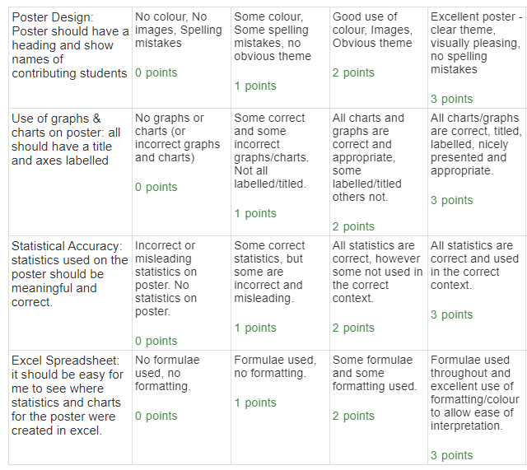

Sample Poster:
The Excel component is an important aspect of this assignment as evidenced in the grading rubric above. Correct facts, figures and accurate graphs and tables on the poster were also required. However, students were encouraged to have fun with the theme of their poster for their final assignment after what had been a long and demanding year. The students did not disappoint!
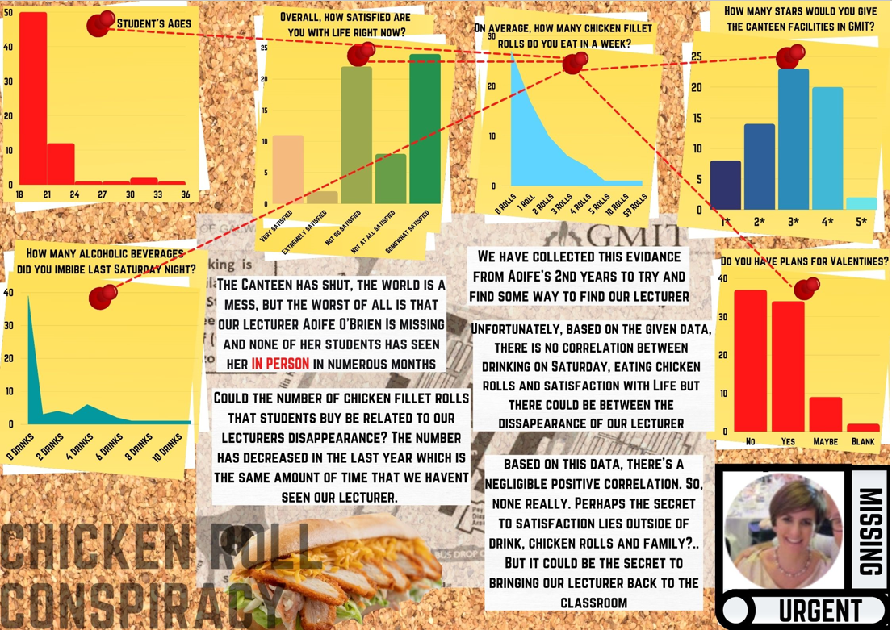

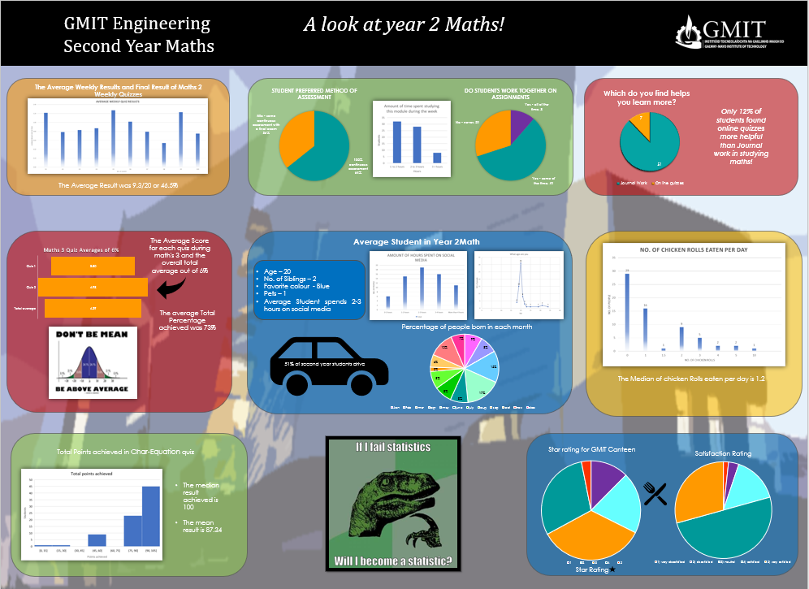

- Immunology contributed by Nigel Francis, Cardiff University
Nigel Francis of Cardiff University offers suggestions on how to move from traditional assignments/ exam questions to more authentic ones.
Immunology Module learning outcomes:
- Discuss detailed aspects of the immune system and apply these to disease processes in humans.
- Analyse and critically evaluate scientific papers that contribute to our current understanding of the immune system in health and disease.
- Interpret and explain experimental data leading to the design and justification of experimental approaches to address a current immunological question.

Traditional exam:
Students were previously asked to answer 4 out of 5 short answer (approx. 250-300 words) questions along the line of “Write brief notes to describe how the complement system can become activated and contribute to the pathogenesis of rheumatoid arthritis.”, “Give two examples of clinical syndromes where severe combined immunodeficiency (SCID) is a feature and write short notes on them.”

Alternative exam: Instead, now they are given interpretative/analytical questions based on primary research papers.

Context: Each lecture topic (~12 subject areas) has an associated core, primary research paper provided by the lecturer. Students are expected to have read the papers ahead of an open book exam.

Authentic exam questions ask students to describe how findings in papers justify the conclusions reached or identify strengths and weakness of the studies and suggest improvements. Normally 5 papers were selected for the exam and students have to answer questions on 4 of them (approx. 300 words per answer).

Justification: Critically evaluating primary research papers is an essential skill that students need to develop during their academic career. Asking analytical questions about primary research is a much more authentic assessment, highlighting those students that really understand the research. Additionally, this approach encourages students to read more widely around the subject areas.
Traditional coursework:
Students would in the past be asked to review the current literature around a disease (linked to current research expertise in the department) and discuss current therapeutic options e.g., “Discuss the use of monoclonal antibody therapeutics in the treatment of rheumatoid arthritis.”

Alternative coursework: Grant application
Context: Students are provided with raw experimental data and asked to analyse and interpret these data. They have to write a short background to the disease area, explain what the data show and suggest the next steps in the research in the form of a short seed corn grant application. Students working in the same subject area are encouraged to discuss the data whilst developing their own research ideas. Students are not assessed on the feasibility of the proposed experiments as they cannot be expected to know what is and isn’t possible at this stage of their academic career, rather on the justification of why experimental approaches were selected.
Justification: For those students looking to go onto postgraduate study, writing research proposals for Masters and PhD positions is becoming increasingly common, this provides an authentic experience for research focused students. For students not looking to enter research, the ability to justify decisions and provided a reasoned argument are essential graduate skills.

4. Group assignment for BSc (Hons) Computer Science Level 5 module: Professional Practice Based on an assignment provided by Chris Headleand, NTF, University of Lincoln
Traditional Essay question:
Pick from one of the following news articles featured recently in the media. Consider and discuss the Social, Ethical, Legal, and Political issues presented. In your essay, make reference to professional codes of conduct, and present a strategy for how the company in question could have avoided these challenges.
Authentic Assessment Example:
Overall task brief: In your allocated working team of four, you will be working over the next six weeks to produce a collective summary proposal to apply for funding from a fictional but feasible funding organisation (4 pages long in Calibri font, font size 12) and present it to a panel of experts. The collective elements of the assignment assessed by the lecturer plus panel of experts will be worth 80%, and all members of the same team will receive the same mark based on this, together with an element of peer review.
Your working processes as a team are an important part of the assignment and you will be asked at the end of the process to anonymously peer review each of the other three members of your team, worth 20% of the assignment under the following criteria:
Information seeking and management: each of you should independently undertake background reading using the guidance notes from the tasks brief, and bring your initial thoughts to meeting 2. Your mark for each of your colleagues will range from 0 (made no contribution) up to 5 (made an outstanding contribution).
Contribution to the group process: enabling others to participate as well as contributing ideas yourself within each of the 4 meetings. Your mark for each of your colleagues will range from 0 (made no or minimal effort to participate in the group process, not turning up for meetings without good reason) up to 5 (was there every time, worked really hard while there).
Production of the team report: Your mark for each of your colleagues will range from 0 (made no contribution at all to writing the final report) up to 5 (made a very significant contribution to writing up a section of the report, fact checking and proofreading the work of others, writing linking sections, completing the reference section).
Presentation of the report in 10 minutes + Q&A (live or on video) to a panel of industry experts: Your mark for each of your colleagues should range from 0 (failed to turn up for the live presentation/ recording, had nothing to say, didn’t attempt to answer any questions) up to 5 (made a solid contribution to the preparation and rehearsal of the presentation, anticipating questions and helping to prepare answers to them, clearly integrating theory and practice).
Your written proposal and the presentation of it should include the following sections.
- Overview / In the first section you should concisely explain to a non-expert audience what your application is.
- Society / In this section explain the challenge you wish to address with your technology, and how it will benefit society.
- Ethical Considerations / In this section explain any potential ethical issues and how you plan to address them.
- Legal / In this section make reference to any relevant legislation and demonstrate how your app will comply with said legislation.
- Political / In this section discuss the impact that the current or future political landscapes could have on your technology and/or how your technology could impact national policy making.
- Conclusion / In your conclusion, discuss any further considerations as you perceive them, and reference any areas of conflict (for example, an ethical issue in conflict with a political one).
At the end of the presentation, you will be asked questions by the panel about the content and potential working of your bid.
5. Architectural History: Thanks to Jemma Bezant of Aberystwyth University for providing the ideas that form the basis of this assignment.

Background
Buildings are some of the most visual reminders of our past heritage and reflect our social, political and cultural histories. All reflect the people that designed, built, and used these structures. This lifelong learning course enables participants to explore the origins of sample buildings, the people and events that shaped its history and how to record and present those data.
Traditional assignment: 3,000-word essay
“What factors constrain conversion and redevelopment of historic Welsh domestic buildings, and what factors need to be taken into account when undertaking conversion work?”
More authentic assessment
Context:
An historic Vicarage in a remote Welsh village has recently changed ownership. The property is un-Listed but with many interesting original features such as sash windows and cast-iron external fittings. The property sits inside extensive mature gardens. The new owners want to convert the four-bedroomed dwelling into a premier B&B and have contracted you to provide them with guidance as to the historic significance of the building and its setting, options for extension and development for the business and advice on the statutory regulations for this historic house and its setting.
Tasks:
- Based on the provided recent sales information from the property, produce a site plan for the property and the gardens that surround it.
- Using physical and digital data sources from publicly-available records in relation to the house and its environs, provide an A4 sheet of bullet points containing relevant background information about the property, including for example, whether any of the trees in the garden are protected.
- Produce a non-expert and illustrated client report to include plans and proposals for the proposed conversion, indicating any key limitations about what can and cannot be done, with reference to local planning laws.
- Draft a covering email to the clients providing summary advice.
.

- Secondary Initial Teacher Education Example provided by Helena Knapton, Edge Hill University.
Authentic assessment has been foundational to the delivery of Secondary PGCE Programmes at Edge Hill University for a number of years. What follows is a fictional example of a traditional approach to delivery together with a modified example of authentic assessment. Many thanks to Helena Knapton, Learning and Teaching Development Lead, Edge Hill University for sharing these ideas.

Developing subject knowledge and pedagogy in Business

Traditional essay example (5000 words)
Review the current Business curricula available in England and its place within the National Curriculum. Critically evaluate how learning theory has influenced the development of the different qualifications available.

Authentic alternative assessment
Instead of the above, students are asked to undertake the following linked tasks, matched to each of the learning outcomes for the module.

Context
The structure of the module is to allow students to develop their subject knowledge and pedagogy throughout the programme. The aim is to support the development of a critically reflective practitioner as well as to address the academic level of the programme.

Assessed components:
- As you have satisfactorily completed of a Subject Knowledge Audit at four key stages of the course demonstrating your understanding and confidence in the subject material that you as a Business teacher may be required to deliver, write a 500-word a critical review of the subject knowledge and understanding in the Business teaching context and indicate any areas you feel require improvement (LO1).
- Review the outcomes of your meetings with school-based mentors and colleagues during your time on placement, using the records of School based trainer meetings, notes from discussions with other members of teaching staff, lesson plans and supporting resources, which evidence your professional development on placement. Write a list of bullet points that indicate your priorities for your further development. (500 words equivalence). (LO2). You may include as appendices additional evidence from interim reviews, End of Professional Practice reports etc. but these will not be included in the word count.
- In negotiation with your tutor, and your school-based mentor, develop a lesson pack of a sequence of 3 one-hour lessons (or equivalent) plus pedagogical justification for their approach. Include within this submission a summary report which demonstrates how your critical understanding of pedagogy of teaching and learning of Business has developed over this time. In this you should reflect on your changing engagement with the programme and comment on the extent to which your Subject Knowledge has become either less or more secure than at the outset of your placement and how confident you are in relation to your teaching capabilities. (2500 words equivalence) (LO3).
- In this final element synthesising and developing learning from the rest of the module, write an evaluation of the teaching materials you prepared in your learning pack in the light of your subsequent thinking during placement and on the course, indicating how you might modify this in future teaching, and what you have learned about yourself over this period. (1500 words).

7. Secondary Teacher Education: Thanks to James Shea of the University of Bedfordshire for the ideas on which this assignment is based. This assignment is on a Post Graduate Certificate in Secondary Education (L7) is called “The Curriculum Specialist”.

Context:
Students on the programme are asked to draw on both subject specific pedagogies and learning theories together when explaining how they go about planning the artefact (in this case a 6-lesson sequence for a small or larger unit of study). Students on the programme cover a large range of subject specialisms so the topics could be as diverse as teaching ‘Throwing the Javelin’ or ‘[the novel] To Kill a Mockingbird’.

Traditional assessment
Typically in the past this would be in the form of a 5,000-word essay.

Authentic assessment activities
For this assignment you are asked to:
i. submit an annotated literature review of an area of teaching you are interested in (e.g. Shakespeare), exploring historic and contemporary approaches to teaching in this area. (500 words).
ii. propose a new approach to teaching this topic, building on learning from within the programme and your reading as prompted by the literature you researched and presented in the literature review. (500 words).
iii. Highlight two key texts which you find convincing and indicate why this is the case. (300 words).
iv. prepare your lesson plans and resources for the six sessions and share these informally with two colleagues on the course for feedback. Keep a note in your diary of any key points they make and how you respond to them.
v. Teach these sessions, making notes in your diary about what went well, and what you would do differently next time. (Up to 500 words in total). Append any comments you had from placement supervisors or pupils in an accompanying appendix.
vi. Prepare and present the outcomes for sharing with your colleagues on the course using a PowerPoint presentation (no more than 10 slides). Depending on the circumstances, you may be asked to present this live on campus or virtually.
vii. Write and submit a 500-word reflection on your learning overall and how you plan to put this into practice in the next stages of your teaching career.

Further useful Resources
You might find these resources sent to us by colleagues helpful in your assessment practice. Thanks Mike Robinson and David O’Sullivan of Sheffield Hallam University for sending us these:
- Feedback ideas from the Department of Engineering and mathematics at Sheffield Hallam University by Mike Robinson and Sue Forder see file:///C:/Users/Sally/Downloads/Feedback%20ideas%202013.pdf
- Grove M, Croft T, Kyle J & Lawson D, (2015) "Providing Effective Feedback” in "Transitions in Undergraduate Mathematics Education"
- Robinson M, Loch B, Croft T (2015) Student Perceptions of Screencast Feedback on Mathematics Assessment. International Journal of Research in Undergraduate Mathematics Education 6.3, 363-385 https://link.springer.com/journal/40753/1/3/page/1
Links to help students with short pitches as part of their assignments:
https://www.vitae.ac.uk/events/three-minute-thesis-competition
https://www.ed.ac.uk/institute-academic-development/postgraduate/doctoral/3mt/about-3mt

Thanks to all our contributors to this compendium. If you would like to contribute to a further future compendium, please contact s.brown@leedsbeckett.ac.uk or kay.sambell@cumbria.ac.uk

​

