**Doing a PhD by Publication: Sally Brown**

**Why do it?**

**How to start?**

**How many journal articles?**

**What about co-authored articles?**

**What about books/textbooks?**

**Finding the golden thread**

**Writing the reflective narrative**

**Managing and organising your PhD studies**

**When to register? What about fees?**

**What support can we get? The value of peer support/critique/ review**

**How long will it take?**

**What order shall I do things?**

**Keeping good records along the way**

**Tricky issues:**

1. **What methodologies have you used and how do you justify them?**
2. **What is your unique contribution to the advancement of knowledge?**
3. **Reviewing the literature in the field**
4. **Producing an advanced critical analysis**
5. **Tone and style**

PhD by Published Work

A Practical Guide for Success Susan Smith (2015)

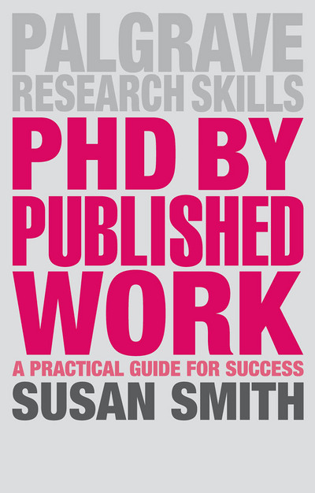

More researchers and academics than ever are now choosing to collate their accumulated published work into a PhD. Universities offer a range of pathways to achieving a PhD by Published Work but there is little guidance available for potential or existing students. This much-needed book provides a practical and comprehensive guide to all aspects of the award.   
  
Informed by surveys of academic staff from around the world, the text provides an honest assessment of the pros and cons of various routes and helps you to select a pathway that's right for you. It demystifies key processes and aspects of the award, such as navigating regulations, writing a synthesis and preparing for a vice voce examination. In addition, the book provides a wealth of guidance on how to maximise the impact of your publication outputs and improve your success rate with journals. Each chapter is enriched with activities, questions and advice from those who have successfully completed the award to help you get the most out of your doctoral experience.

|  |
| --- |
|  |